**Diff Films Website Structure**

When first setting out to create this website my aim was to create a portfolio archive of the films produced by the society with the target audience being people who are looking to potentially hire the society to produce future content. Like other portfolio websites I wanted the design to be simple and stylish in order to represent the quality of work that can be created.

I started my design by thinking about how I would want the archive pages to look – opting for a design which would create a jigsaw of pieces made out of stills from each film that was represented. From a design perspective I think it is important that the colour scheme compliments the images and so promotes the films individual cinematography. By uploading the still to color.adobe.com I was able to analyse the colours in the compositions of the images and get the HEX number. 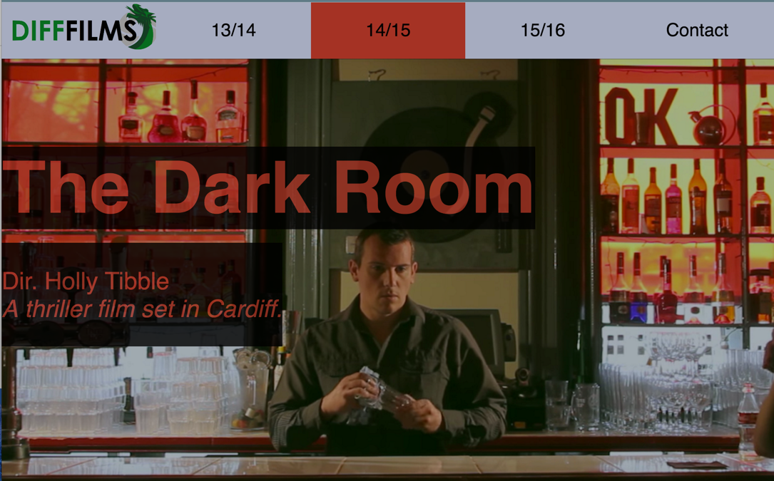

You can see in this still the red colour for the active page and the font is chosen specifically to compliment the still from the film. When hovering over the tabs the same red also appears. Although I was initially concerned this style may mean the pages look inconsistent – I think it works well as a constant theme by having the colours change to reflect the stills – while the grey header and logo stay constant.

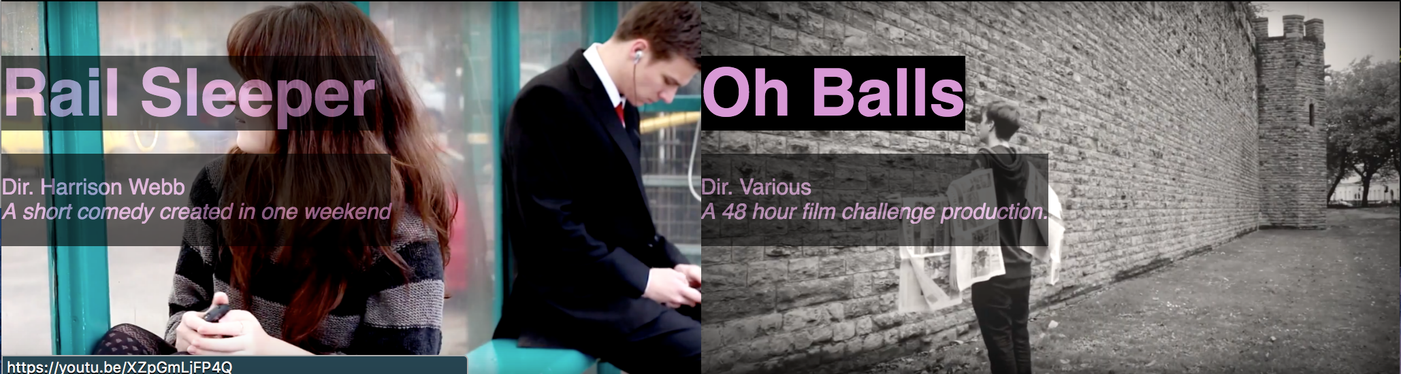

In this still you can see the film title ‘Oh Balls’ is highlighted by the mouse, while ‘Rail Sleeper’ isn’t – this emphasises that the image is an active link to the film’s YouTube page and adds interactivity to the website. I chose to make the fonts slightly opaque to allow the stills to be seen with greater clarity – because of the black background I do not believe the text is hard to read and neither did the audience I have shown the website to.

It was important to me that the website was responsive to different sizes of browsers and when viewed on a phone or tablet. I initially built the website to work on a full screen browser then slowly lowered the pixel width, adding a media query when needed, so that it would work on the phones displayed on Google Chrome’s Developer Tools option. The biggest challenge was making sure the text and the images could still both be seen easily. I made the decision to rescale the images at lower pixel widths so that they would still maintain some height and so could have text on top of them still. Below we see the same page on a browser compared to a Galaxy S5, you can see on the S5 the picture has been cropped but all the text is still displayed and the design is still consistent on both.

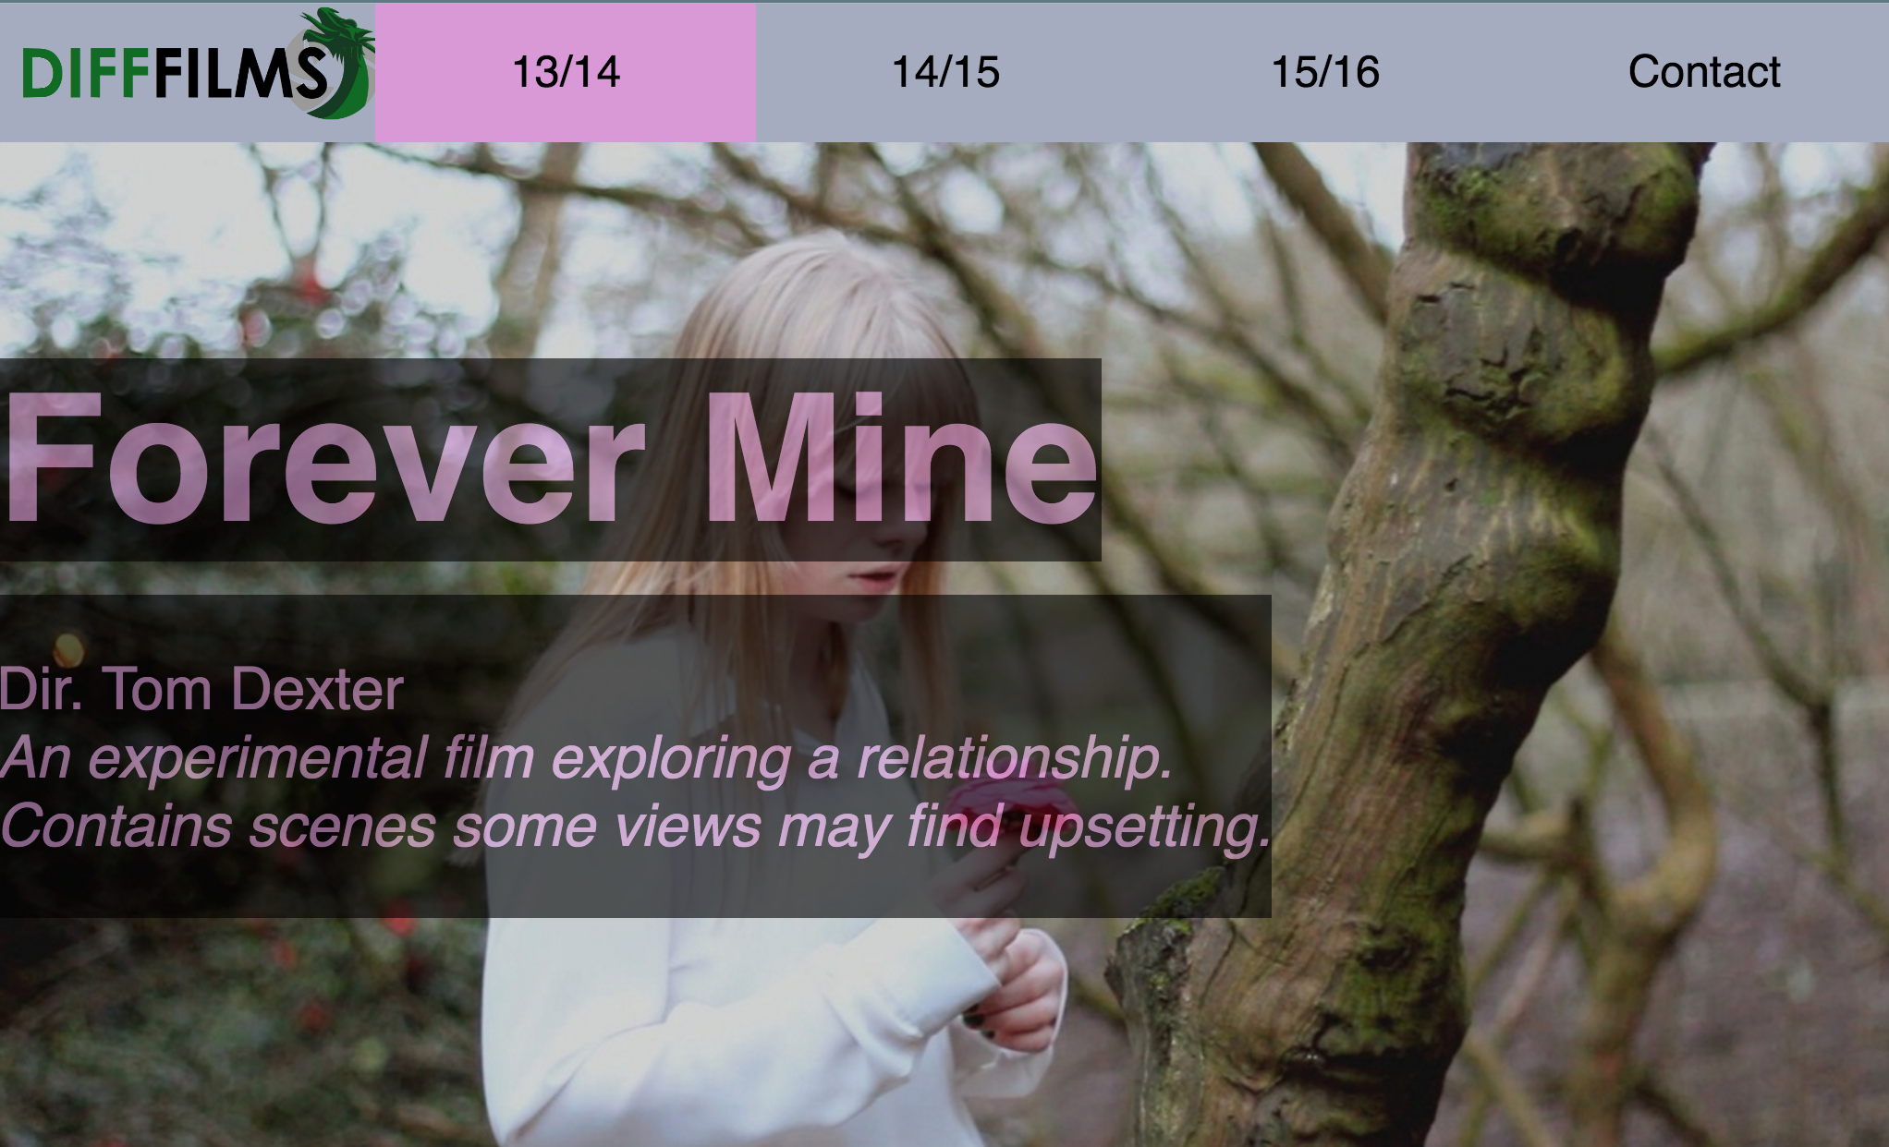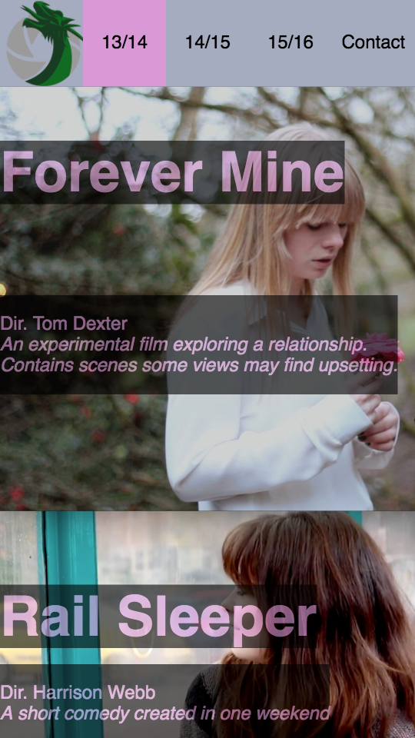

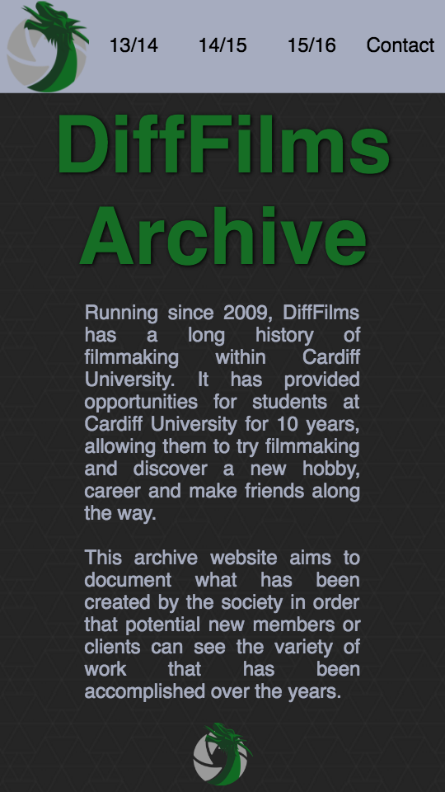Another thing to notice on the above pictures is the change in logo, the smaller width meant less space for the navigation bar – I therefore opted to have a version of the logo without the full title of the society in favour of clearly displaying the whole navigation bar. I don’t believe not having the full society title is an issue as the Homepage will be the main landing page for users as they would be linked to it from the university website or the Facebook page of the society.

Looking at the homepage for the website you can notice it has a minimalist design. Using a repeating image for a background design from [www.subtlepatterns.com](http://www.subtlepatterns.com) I was able to make the page look fresh while keeping the information easy to read. For the main title ‘DiffFilms Archive’ I chose the same colour as the logo and gave a slight show to the font to make it stand out. The hover for the navigation bar is the light green in the logo, I chose not to have it glowing as an active page on the home page though. I did this as to not to detract from the society’s logo which I had commissioned last year.

I chose to put the logo again at the bottom of the page a period for the end of the page.

If I was to revisit the page after learning JavaScript I would keep the mobile homepage the same but perhaps add a twitter feed to the societys’ account on their main homepage.

Website Validation

To check my website I first navigated through the website manually checking each of the links worked and that the website was readable at different scales – manually changing my browsers size and checking how it looked on various mobile devices. I also got users who don’t know code to click around the site to make sure it was user friendly.

I used the code validator at <https://validator.w3.org/> to upload my code to validate it. It showed me to change the comments from <! Comment here > to <!-- Comment here -->. One example of this is shown here - 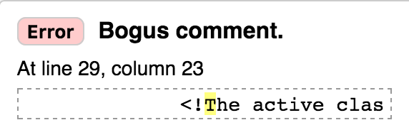- I have since edited the code to rectify this mistake.

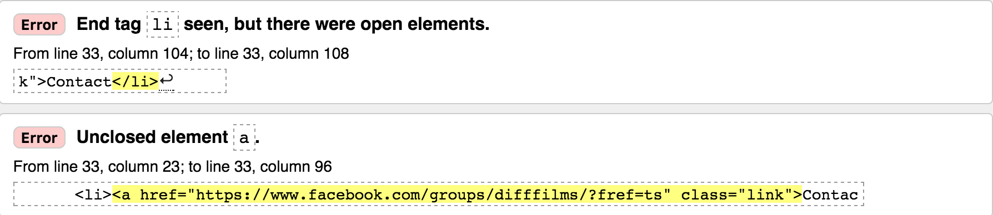

I also didn’t close the a element in my navigation bar and with some of the YouTube link – I have since gone back and closed the a elements by using ctrl+f to search for ‘a href’ in all the documents.

For the below validation error I attempted to add a ul to the navigation bar – however it changed the layout slightly and as it already worked perfectly before I have decided not to to take action on this validation error.

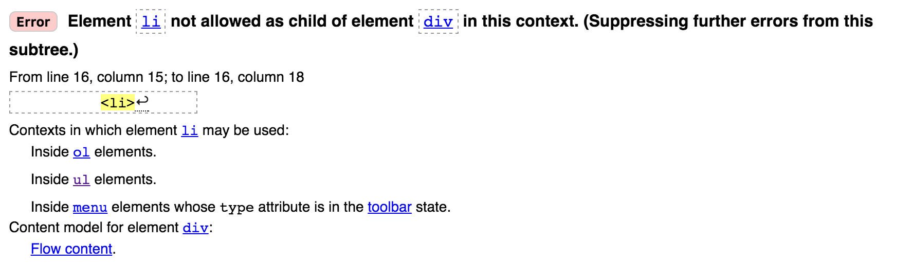

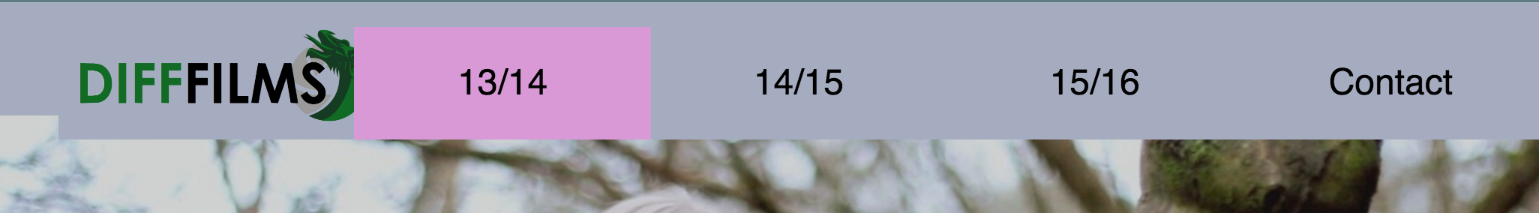

Using the CSS validator I was able to find some bits of code which weren’t doing anything in my CSS as they existed from the intial stages of designing when I was trying to make things work.

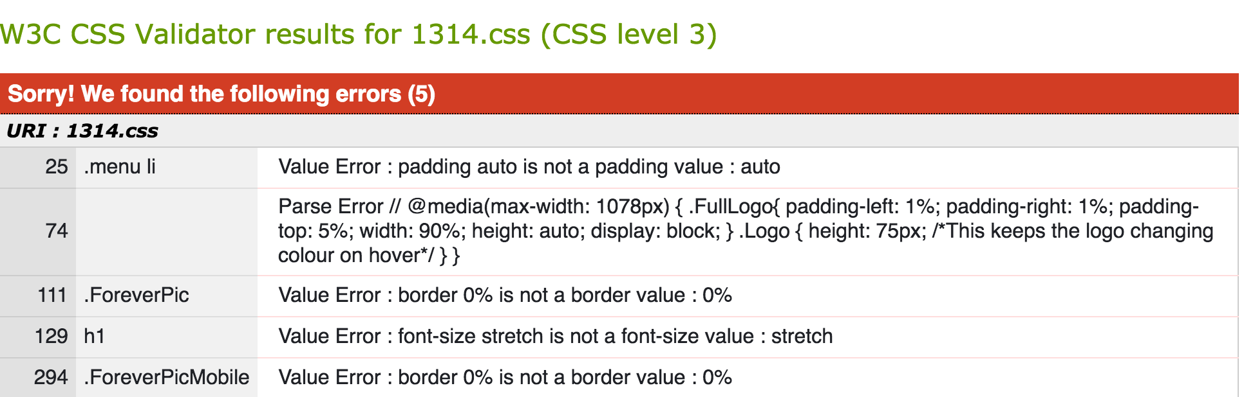

I have since gone through and removed these errors – although I have ignored the parse error it is likely only one character in the code. Upon relooking at my website these changes have not affected the look of the page.

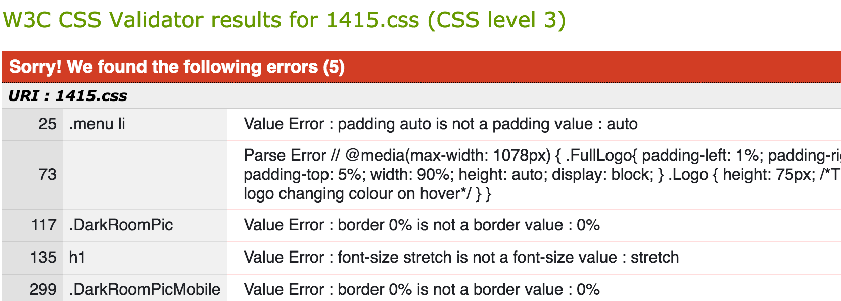

The same errors were found in the 1415 code and I have also corrected them in here and the code for 1516.

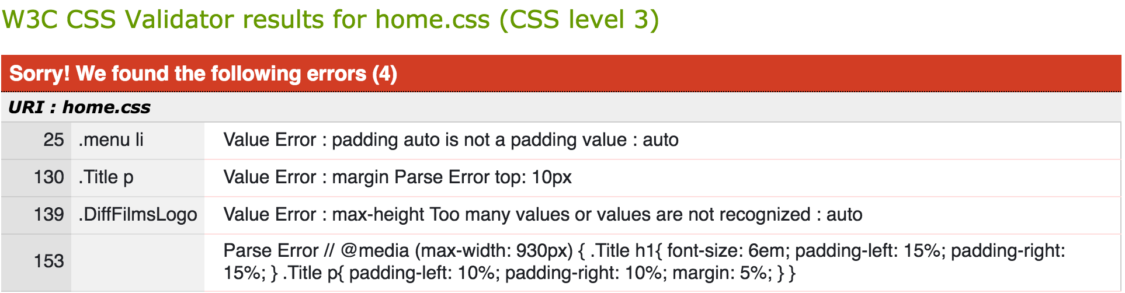

On home.css I found the parse error that I had written ‘margin top’ instead of ‘margin-top’ and so corrected this.

Reflection

Overall I am very pleased with how my website turned out. I believe that taking time to sketch out the website design before and think about what the aim of my website would be helped me to keep focussed on different tasks and helped me think more laterally about how I was going to overcome certain problems.

I am glad that I did the validation, as it allowed me to see some of the useless bits of code which remained from when I started coding – showing that I have developed and learned a lot about coding and design while creating the website. The validation also helped me clarify certain rules. I believe this demonstrates that I can use the browser debugging tools – as well as my use of developer tools to test the responsiveness of the design.

The society are keen to use the code to host an archive and so once I know enough JavaScript I think I will try to return to the code to add a Twitter feed onto the homepage when the browser is big enough. The fact that they think the website is better than their Weebly one I think shows that I can created HTML pages and so fulfilled the learning outcome.

I think the code is written clearly in a way that it is obvious as to what bit of text should be edited if they want to add any information about the films or correct my descriptions of the films – as I was focussed on the design rather than content of the text.

I am pleased with the overall design of the website and believe that using the colours in the photos for the header bar and fonts really helped push the design to make it all flow together and complement the stills. I have shown that I can use CSS rules to position text and images effectively. In particular using functions like opacity to increase ease of use by the user to show where links are. I have also used media queries effectively to make sure the pages are responsive and shown at their best at every width.